
It is a Spring module which provides RAD (Rapid Application Development) feature to Spring framework. It is used to create standalone spring based application that you can just run because it needs very little spring configuration.
Spring Boot does not generate code and there is absolutely no requirement for XML configuration. It uses convention over configuration software design paradigm that means it decrease the effort of developer.
- Create stand-alone Spring applications that can be started using java -jar.
- Embed Tomcat, Jetty or Undertow directly. You don't need to deploy WAR files.
- It provides opinionated 'starter' POMs to simplify your Maven configuration.
- It automatically configure Spring whenever possible.
- It provides production-ready features such as metrics, health checks and externalized configuration.
- Absolutely no code generation and no requirement for XML configuration.
- It is very easy to develop Spring Based applications with Java or Groovy.
- It reduces lots of development time and increases productivity.
- It avoids writing lots of boilerplate Code, Annotations and XML Configuration.
- It is very easy to integrate Spring Boot Application with its Spring Ecosystem like Spring JDBC, Spring ORM, Spring Data, Spring Security etc.
- It follows “Opinionated Defaults Configuration” Approach to reduce Developer effort
- It provides Embedded HTTP servers like Tomcat, Jetty etc. to develop and test our web applications very easily.
- It provides CLI (Command Line Interface) tool to develop and test Spring Boot(Java or Groovy) Applications from command prompt very easily and quickly.
- It provides lots of plugins to develop and test Spring Boot Applications very easily using Build Tools like Maven and Gradle.
- It provides lots of plugins to work with embedded and in-memory Databases very easily.
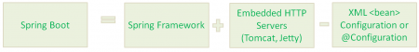
There are multiple approaches to create Spring Boot project. We can use any of the following approach to create application.
- Spring Maven Project
- Spring Starter Project Wizard
- Spring Initializer
- Spring Boot CLI
- Spring Boot Maven Project
Creating Spring Boot project by creating maven project. It includes the following steps.
- Select project type.
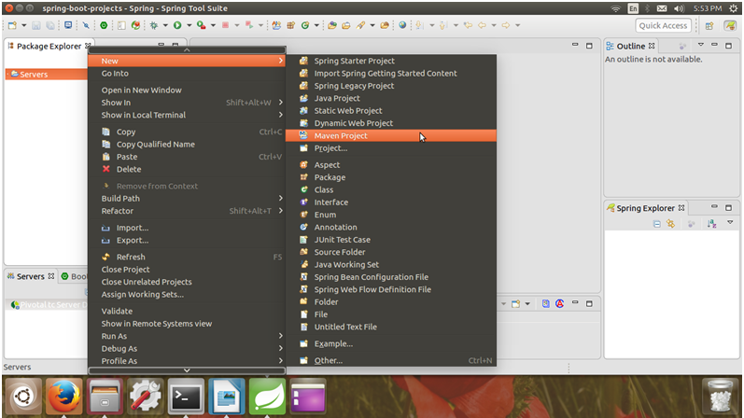
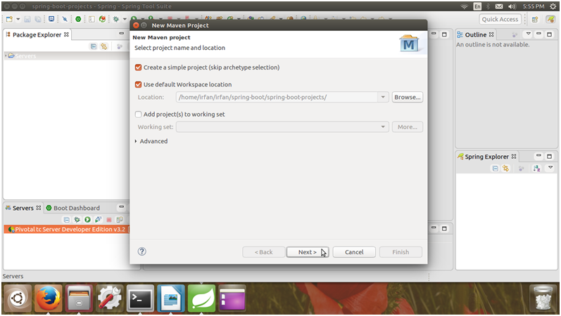
Configure project by providing project name.
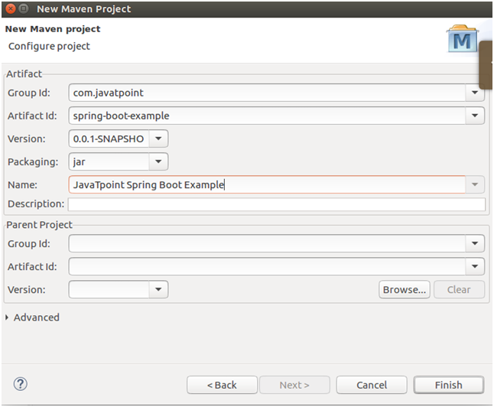
After clicking finish, Spring boot project has been created. Our new project looks like the following screen shot.
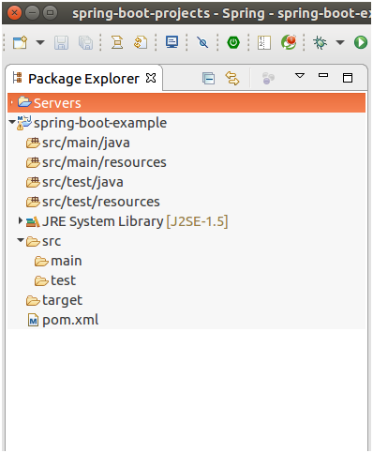
This Maven project has a pom.xml file which contains the following default configuration.
// pom.xml
<project xmlns="http://maven.apache.org/POM/4.0.0" xmlns:xsi="http://www.w3.org/2001/XMLSchema-instance" xsi:schemaLocation="http://maven.apache.org/POM/4.0.0 http://maven.apache.org/xsd/maven-4.0.0.xsd">
<modelVersion>4.0.0</modelVersion>
<groupId>com.javatpoint</groupId>
<artifactId>spring-boot-example</artifactId>
<version>0.0.1-SNAPSHOT</version>
<name>JavaTpoint Spring Boot Example</name>
</project>
We need to configure it in order to make it a Spring Boot project. Here, we are adding parent to our Maven project. It is used to declare that our project is a child to this parent project.

<parent>
<groupId>org.springframework.boot</groupId>
<artifactId>spring-boot-starter-parent</artifactId>
<version>1.4.2.RELEASE</version>
</parent>
After that add the following dependency to the pom.xml file. Here, we are adding web dependency by adding spring-boot-starter-web.
<dependencies>
<dependency>
<groupId>org.springframework.boot</groupId>
<artifactId>spring-boot-starter-web</artifactId>
</dependency>
</dependencies>
After that add Java version for the project.
<properties>
<java.version>1.8</java.version>
</properties>
Now, our project should have the following directly structure. You can notice that maven has created a new dependency folder to store the jar files.
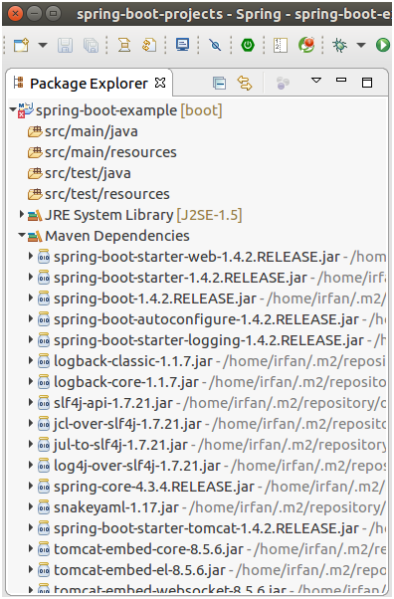
Update Maven project each time after including new dependencies.
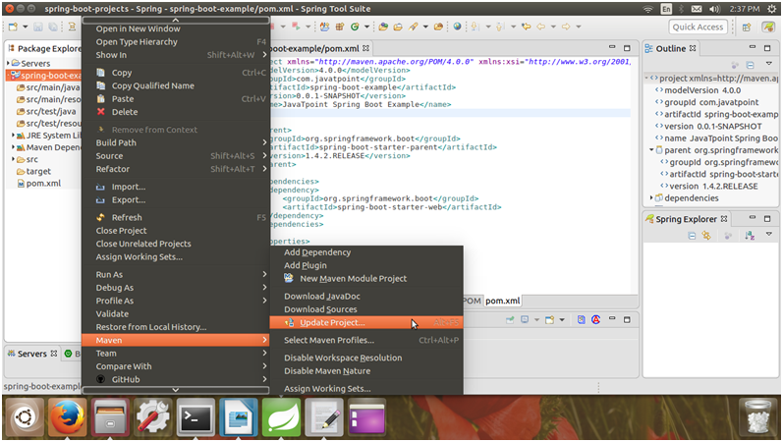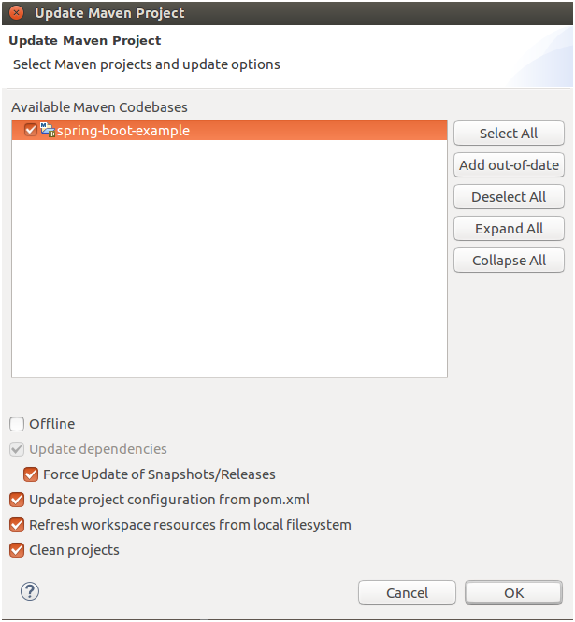
After updating Maven. Now, let's make it runnable. Create a Java class inside the src/main/java package.
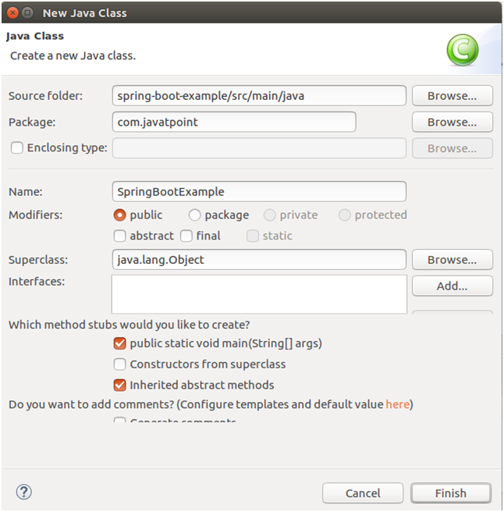
After creating class call the static run method of SpringApplication class. In the following code, we are calling run method and passing class name as argument.

// SpringBootExample.java
package com.javatpoint;
import org.springframework.boot.SpringApplication;
import org.springframework.boot.autoconfigure.SpringBootApplication;
@SpringBootApplication
publicclass SpringBootExample {
publicstaticvoid main(String[] args) {
SpringApplication.run(SpringBootExample.class, args);
}
}
Now, run this class as a Java Application.
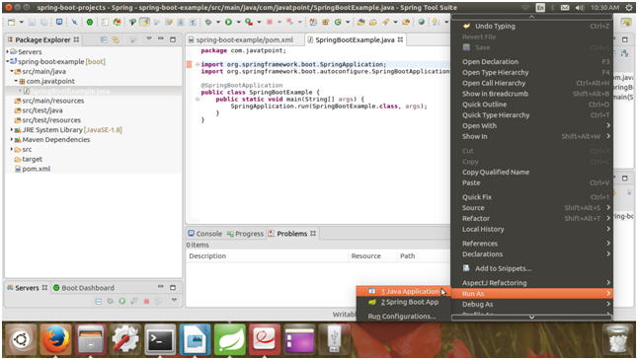
It displays the following output.
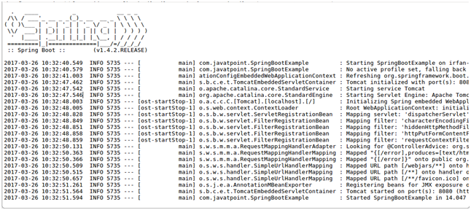
The line Started SpringBootExample in 14.047 seconds (JVM running for 17.391) in output window shows that our application is started.
- Spring Starter Project Wizard
Select Starter Project
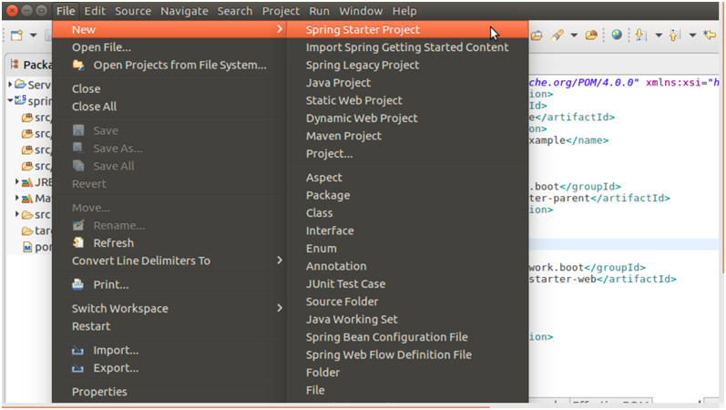
Provide project details.
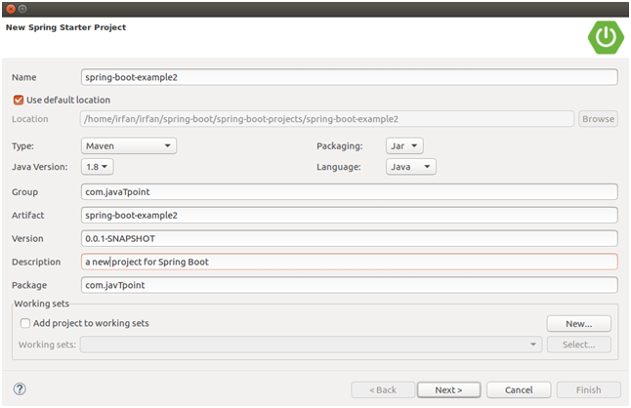
Select dependency as web to create web project.
After finishing, the default pom.xml file for the project is created as below:
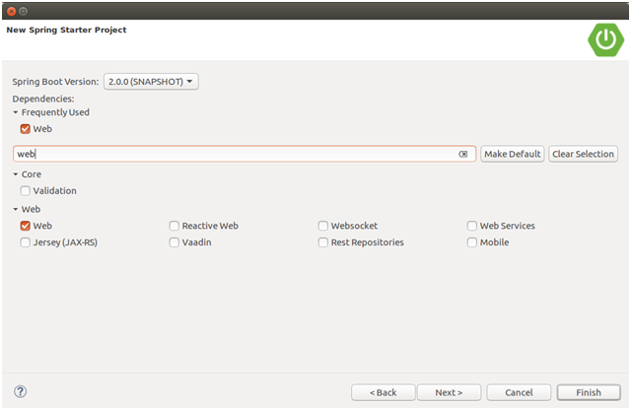
// pom.xml
<?xmlversionxmlversion="1.0"encoding="UTF-8"?>
<projectxmlnsprojectxmlns="http://maven.apache.org/POM/4.0.0"xmlns:xsi="http://www.w3.org/2001/XMLSchema-instance"
xsi:schemaLocation="http://maven.apache.org/POM/4.0.0 http://maven.apache.org/xsd/maven-4.0.0.xsd">
<modelVersion>4.0.0</modelVersion>
<groupId>com.javatpoint</groupId>
<artifactId>new-spring-boot-example2</artifactId>
<version>0.0.1-SNAPSHOT</version>
<packaging>jar</packaging>
<name>spring-boot-example2</name>
<description>a new project for Spring Boot</description>
<parent>
<groupId>org.springframework.boot</groupId>
<artifactId>spring-boot-starter-parent</artifactId>
<version>2.0.0.BUILD-SNAPSHOT</version>
<relativePath/><!-- lookup parent from repository -->
</parent>
<properties>
<project.build.sourceEncoding>UTF-8</project.build.sourceEncoding>
<project.reporting.outputEncoding>UTF-8</project.reporting.outputEncoding>
<java.version>1.8</java.version>
</properties>
<dependencies>
<dependency>
<groupId>org.springframework.boot</groupId>
<artifactId>spring-boot-starter-web</artifactId>
</dependency>
<dependency>
<groupId>org.springframework.boot</groupId>
<artifactId>spring-boot-starter-test</artifactId>
<scope>test</scope>
</dependency>
</dependencies>
<build>
<plugins>
<plugin>
<groupId>org.springframework.boot</groupId>
<artifactId>spring-boot-maven-plugin</artifactId>
</plugin>
</plugins>
</build>
<repositories>
<repository>
<id>spring-snapshots</id>
<name>Spring Snapshots</name>
<url>https://repo.spring.io/snapshot</url>
<snapshots>
<enabled>true</enabled>
</snapshots>
</repository>
<repository>
<id>spring-milestones</id>
<name>Spring Milestones</name>
<url>https://repo.spring.io/milestone</url>
<snapshots>
<enabled>false</enabled>
</snapshots>
</repository>
</repositories>
<pluginRepositories>
<pluginRepository>
<id>spring-snapshots</id>
<name>Spring Snapshots</name>
<url>https://repo.spring.io/snapshot</url>
<snapshots>
<enabled>true</enabled>
</snapshots>
</pluginRepository>
<pluginRepository>
<id>spring-milestones</id>
<name>Spring Milestones</name>
<url>https://repo.spring.io/milestone</url>
<snapshots>
<enabled>false</enabled>
</snapshots>
</pluginRepository>
</pluginRepositories>
</project>
This project auto generates a Java file as given below inside the src/main/java.
package com.javtpoint;
import org.springframework.boot.SpringApplication;
import org.springframework.boot.autoconfigure.SpringBootApplication;

@SpringBootApplication
public class SpringBootExample2Application {

public static void main(String[] args) {
SpringApplication.run(SpringBootExample2Application.class, args);
}
}
Now we can run this as a Java Application and it will produce the following output.
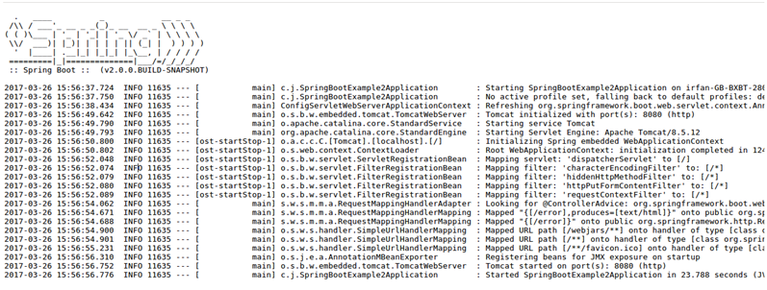
Observe the line Started SpringBootExample2Application in 23.788 seconds (JVM running for 30.19) in the output section. It shows that our application is started.
- Spring Initializr
It is a web tool which is provided by Spring on official site. You can create Spring Boot project by providing project details.
Select Maven project and dependencies. Fill other details and click on generate project.
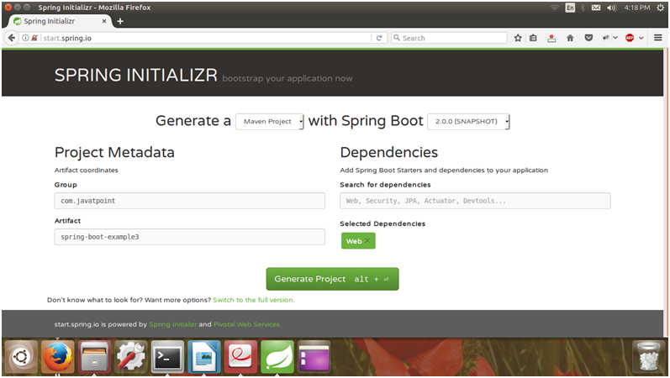
After clicking it asked for download project.
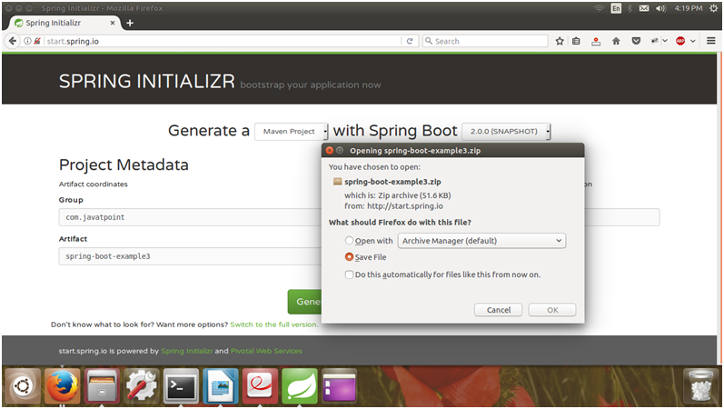
Save project and extract it.
Now import this project by using import option from the STS (Spring Tool Suite) IDE.
Importing project
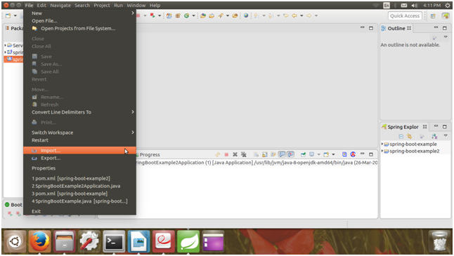

Select project type in Maven.
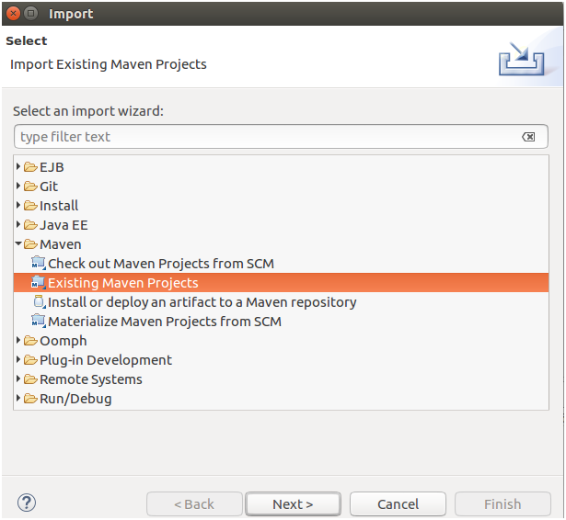
Select source project
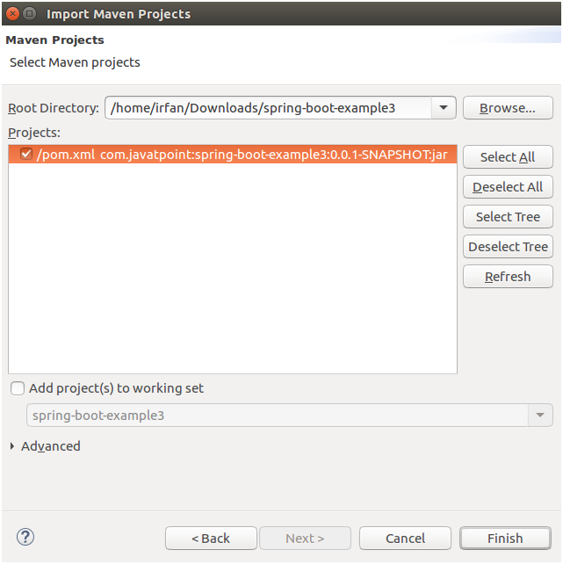
After finishing, our Spring Boot Project should look like this.
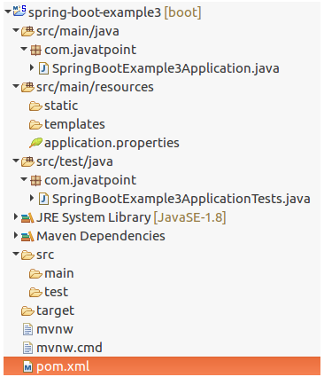
It has a pom.xml file which contains all the dependencies and configuration for the project. It should look like this.
// pom.xml
<?xml version="1.0" encoding="UTF-8"?>
<project xmlns="http://maven.apache.org/POM/4.0.0" xmlns:xsi="http://www.w3.org/2001/XMLSchema-instance"
xsi:schemaLocation="http://maven.apache.org/POM/4.0.0 http://maven.apache.org/xsd/maven-4.0.0.xsd">
<modelVersion>4.0.0</modelVersion>

<groupId>com.javatpoint</groupId>
<artifactId>spring-boot-example3</artifactId>
<version>0.0.1-SNAPSHOT</version>
<packaging>jar</packaging>

<name>spring-boot-example3</name>
<description>Demo project for Spring Boot</description>

<parent>
<groupId>org.springframework.boot</groupId>
<artifactId>spring-boot-starter-parent</artifactId>
<version>2.1.0.BUILD-SNAPSHOT</version>
<relativePath/> <!-- lookup parent from repository -->
</parent>

<properties>
<project.build.sourceEncoding>UTF-8</project.build.sourceEncoding>
<project.reporting.outputEncoding>UTF-8</project.reporting.outputEncoding>
<java.version>1.8</java.version>
</properties>

<dependencies>
<dependency>
<groupId>org.springframework.boot</groupId>
<artifactId>spring-boot-starter-web</artifactId>
</dependency>

<dependency>
<groupId>org.springframework.boot</groupId>
<artifactId>spring-boot-starter-test</artifactId>
<scope>test</scope>
</dependency>
</dependencies>

<build>
<plugins>
<plugin>
<groupId>org.springframework.boot</groupId>
<artifactId>spring-boot-maven-plugin</artifactId>
</plugin>
</plugins>
</build>

<repositories>
<repository>
<id>spring-snapshots</id>
<name>Spring Snapshots</name>
<url>https://repo.spring.io/snapshot</url>
<snapshots>
<enabled>true</enabled>
</snapshots>
</repository>
<repository>
<id>spring-milestones</id>
<name>Spring Milestones</name>
<url>https://repo.spring.io/milestone</url>
<snapshots>
<enabled>false</enabled>
</snapshots>
</repository>
</repositories>

<pluginRepositories>
<pluginRepository>
<id>spring-snapshots</id>
<name>Spring Snapshots</name>
<url>https://repo.spring.io/snapshot</url>
<snapshots>
<enabled>true</enabled>
</snapshots>
</pluginRepository>
<pluginRepository>
<id>spring-milestones</id>
<name>Spring Milestones</name>
<url>https://repo.spring.io/milestone</url>
<snapshots>
<enabled>false</enabled>
</snapshots>
</pluginRepository>
</pluginRepositories>
</project>
It also generates a Java file in the src/main/java directory. This file has same name as you mentioned in artifact. The default created Java file is the below.
// SpringBootExample3Application.java
package com.javatpoint;
import org.springframework.boot.SpringApplication;
import org.springframework.boot.autoconfigure.SpringBootApplication;
@SpringBootApplication
public class SpringBootExample3Application {

public static void main(String[] args) {
SpringApplication.run(SpringBootExample3Application.class, args);
}
}
We can run this project by selecting Java Application from run options . After running, it produces the following output.
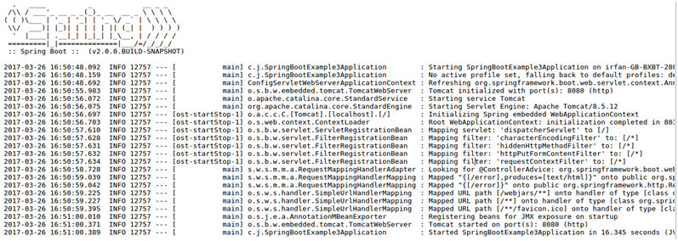
Observe the line Started SpringBootExample3Application in 16.345 seconds (JVM running for 19.909). It shows that the Spring Boot application has started.
- Spring Boot CLI

It is a tool which you can download from the official site of Spring Framework. Here, we are explaining steps. Download the CLI tool from official site as we are doing here.

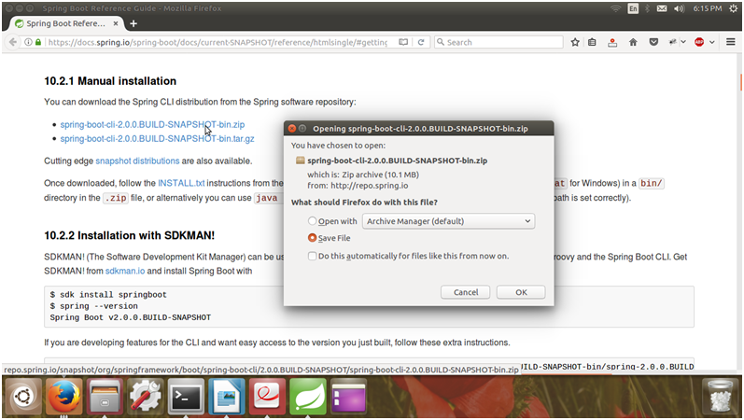

Create a controller in the groovy file with file name: SpringBootCliExample.groovy

@RestController

class SpringBootCliExample {

@RequestMapping("/cli-example")

String index() {

"Spring Boot Example using Cli is Running Successfully.";

}

}

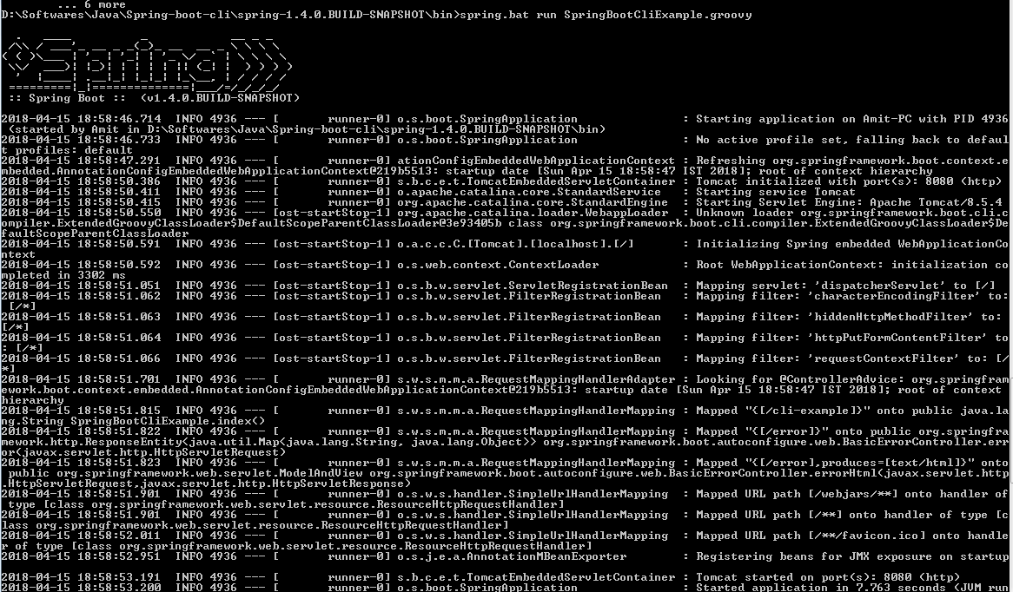

This project is running on the port 8080. So, we can invoke it on any browser by using the following url.

http://localhost:8080/cli-example

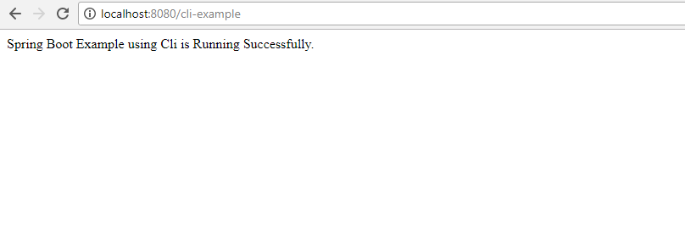

- Spring Boot Starters
Starters are a set of convenient dependency descriptors which we can include in our application.Spring Boot provides built-in starters which makes development easier and rapid. For example, if we want to get started using Spring and JPA for database access, just include the spring-boot-starter-data-jpa dependency in your project.
Starter should follow a naming pattern like: spring-boot-starter-*, where * is a particular type of application. This naming structure is intended to help when you need to find a starter.
The following application starters are provided by Spring Boot under the org.springframework.boot group:
Name | Description
spring-boot-starter-thymeleaf | It is used to build MVC web applications using Thymeleaf views.
spring-boot-starter-data-couchbase | This is used for Couchbase document-oriented database and Spring Data Couchbase.
spring-boot-starter-artemis | It is used for JMS messaging using Apache Artemis.
spring-boot-starter-web-services | It is used for Spring Web Services.
spring-boot-starter-mail | It is used to support Java Mail and Spring Framework's email sending.
spring-boot-starter-data-redis | It is used for Redis key-value data store with Spring Data Redis and the Jedis client.
spring-boot-starter-web | It is used for building web, including RESTful, applications using Spring MVC. Uses Tomcat as the default embedded container.
spring-boot-starter-data-gemfire | It is used to GemFire distributed data store and Spring Data GemFire.
spring-boot-starter-activemq | It is used to JMS messaging using Apache ActiveMQ.
spring-boot-starter-data-elasticsearch | It is used to Elasticsearch search and analytics engine and Spring Data Elasticsearch.
spring-boot-starter-integration | It is used for Spring Integration.
spring-boot-starter-test | It is used to test Spring Boot applications with libraries including JUnit, Hamcrest and Mockito.
spring-boot-starter-jdbc | It is used for JDBC with the Tomcat JDBC connection pool.
spring-boot-starter-mobile | It is used for building web applications using Spring Mobile.
spring-boot-starter-validation | It is used for Java Bean Validation with Hibernate Validator.
spring-boot-starter-hateoas | It is used to build hypermedia-based RESTful web application with Spring MVC and Spring HATEOAS.
spring-boot-starter-jersey | It is used to build RESTful web applications using JAX-RS and Jersey. An alternative to spring-boot-starter-web.
spring-boot-starter-data-neo4j | It is used for Neo4j graph database and Spring Data Neo4j.
spring-boot-starter-data-ldap | It is used for Spring Data LDAP.
spring-boot-starter-websocket | It is used for building WebSocket. applications using Spring Framework?s WebSocket support.
spring-boot-starter-aop | It is used for aspect-oriented programming with Spring AOP and AspectJ.
spring-boot-starter-amqp | It is used for Spring AMQP and Rabbit MQ.
spring-boot-starter-data-cassandra | It is used for Cassandra distributed database and Spring Data Cassandra.
spring-boot-starter-social-facebook | It is used for Spring Social Facebook.
spring-boot-starter-jta-atomikos | It is used for JTA transactions using Atomikos.
spring-boot-starter-security | It is used for Spring Security.
spring-boot-starter-mustache | It is used for building MVC web applications using Mustache views.
spring-boot-starter-data-jpa | It is used for Spring Data JPA with Hibernate.
spring-boot-starter | It is used for core starter, including auto-configuration support, logging and YAML.
spring-boot-starter-groovy-templates | It is used for building MVC web applications using Groovy Templates views.
spring-boot-starter-freemarker | It is used for building MVC web applications using FreeMarker views.
spring-boot-starter-batch | It is used for Spring Batch.
spring-boot-starter-social-linkedin | It is used for Spring Social LinkedIn.
spring-boot-starter-cache | It is used for Spring Framework?s caching support.
spring-boot-starter-data-solr | It is used for the Apache Solr search platform with Spring Data Solr.
spring-boot-starter-data-mongodb | It is used for MongoDB document-oriented database and Spring Data MongoDB.
spring-boot-starter-jooq | It is used for jOOQ to access SQL databases. An alternative to spring-boot-starter-data-jpa or spring-boot-starter-jdbc.
spring-boot-starter-jta-narayana | It is used for Spring Boot Narayana JTA Starter.
spring-boot-starter-cloud-connectors | It is used for Spring Cloud Connectors which simplifies connecting to services in cloud platforms like Cloud Foundry and Heroku.
spring-boot-starter-jta-bitronix | It is used for JTA transactions using Bitronix.
spring-boot-starter-social-twitter | It is used for Spring Social Twitter.
spring-boot-starter-data-rest | It is used for exposing Spring Data repositories over REST using Spring Data REST.

Spring Boot production starters
Name | Description
spring-boot-starter-actuator | It is used for Spring Boot?s Actuator which provides production ready features to help you monitor and manage your application.
spring-boot-starter-remote-shell | It is used for the CRaSH remote shell to monitor and manage your application over SSH. Deprecated since 1.5.

Spring Boot technical starters
Name | Description
spring-boot-starter-undertow | It is used for Undertow as the embedded servlet container. An alternative to spring-boot-starter-tomcat.
spring-boot-starter-jetty | It is used for Jetty as the embedded servlet container. An alternative to spring-boot-starter-tomcat.
spring-boot-starter-logging | It is used for logging using Logback. Default logging starter.
spring-boot-starter-tomcat | It is used for Tomcat as the embedded servlet container. Default servlet container starter used by spring-boot-starter-web.
spring-boot-starter-log4j2 | It is used for Log4j2 for logging. An alternative to spring-boot-starter-logging.
- Spring Boot JPA

Spring Boot provides spring-boot-starter-data-jpa starter to connect Spring application with relational database efficiently. You can use it into project POM (Project Object Model) file.
- Project Structure:

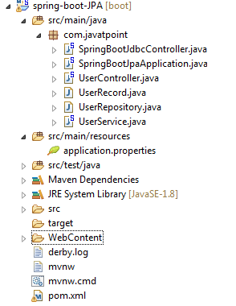
- Pom.xml:
<?xml version="1.0" encoding="UTF-8"?>
<project xmlns="http://maven.apache.org/POM/4.0.0" xmlns:xsi="http://www.w3.org/2001/XMLSchema-instance"
xsi:schemaLocation="http://maven.apache.org/POM/4.0.0 http://maven.apache.org/xsd/maven-4.0.0.xsd">
<modelVersion>4.0.0</modelVersion>

<groupId>com.javatpoint</groupId>
<artifactId>spring-boot-JPA</artifactId>
<version>0.0.1-SNAPSHOT</version>
<packaging>jar</packaging>

<name>spring-boot-JPA</name>
<description>A new project of Spring Boot JPA</description>

<parent>
<groupId>org.springframework.boot</groupId>
<artifactId>spring-boot-starter-parent</artifactId>
<version>1.5.9.RELEASE</version>
<relativePath />
</parent>

<properties>
<project.build.sourceEncoding>UTF-8</project.build.sourceEncoding>
<project.reporting.outputEncoding>UTF-8</project.reporting.outputEncoding>
<java.version>1.8</java.version>
</properties>

<dependencies>
<dependency>
<groupId>org.springframework.boot</groupId>
<artifactId>spring-boot-starter-data-jpa</artifactId>
</dependency>

<dependency>
<groupId>org.springframework.boot</groupId>
<artifactId>spring-boot-starter-web</artifactId>
</dependency>

<!-- MySQL database driver -->
<dependency>
<groupId>mysql</groupId>
<artifactId>mysql-connector-java</artifactId>
<version>5.1.9</version>
</dependency>

<dependency>
<groupId>org.springframework.boot</groupId>
<artifactId>spring-boot-starter-test</artifactId>
<scope>test</scope>
</dependency>
</dependencies>

<build>
<plugins>
<plugin>
<groupId>org.springframework.boot</groupId>
<artifactId>spring-boot-maven-plugin</artifactId>
</plugin>
</plugins>
</build>
</project>
- application.properties

spring.datasource.url=jdbc:mysql://localhost:3306/springbootdb

spring.datasource.username=root

spring.datasource.password=

spring.jpa.hibernate.ddl-auto=create-drop

server.port=8085
- UserRecord.java:
package com.javatpoint;
import javax.persistence.Entity;
import javax.persistence.Id;
@Entity
public class UserRecord {
@Id
private String id;
private String name;
private String email;

public UserRecord() {
}

public String getId() {
return id;
}

public void setId(String id) {
this.id = id;
}

public String getName() {
return name;
}

public void setName(String name) {
this.name = name;
}

public String getEmail() {
return email;
}

public void setEmail(String email) {
this.email = email;
} }
- UserRepository.java:
package com.javatpoint;

import org.springframework.data.jpa.repository.JpaRepository;
public interface UserRepository extends JpaRepository<UserRecord, String> {

}
- UserService.java:
package com.javatpoint;
import java.util.List;
import javax.annotation.Resource;
import org.springframework.beans.factory.annotation.Autowired;
import org.springframework.stereotype.Service;

@Service
public class UserService {
@Autowired
@Resource
private UserRepository userRepository;
public List<UserRecord> getAllUsers(){
return userRepository.findAll();
}

public UserRecord getUser(String id){
return userRepository.findOne(id);
}

public void addUser(UserRecord userRecord){
userRepository.save(userRecord);
}

public void deleteUser(String id){
userRepository.delete(id);
}

public UserRecord updateUser(UserRecord user) {
UserRecord updatedUser = userRepository.findOne(user.getId());
updatedUser.setId(user.getId());
updatedUser.setName(user.getName());
updatedUser.setEmail(user.getEmail());
System.out.println("Id="+updatedUser.getId()+"\tName="+updatedUser.getName()+"\tEmail="+updatedUser.getEmail());
return updatedUser;
}
}
- UserController.java:
package com.javatpoint;
import java.util.List;
import org.springframework.beans.factory.annotation.Autowired;
import org.springframework.web.bind.annotation.PathVariable;
import org.springframework.web.bind.annotation.RequestBody;
import org.springframework.web.bind.annotation.RequestMapping;
import org.springframework.web.bind.annotation.RequestMethod;
import org.springframework.web.bind.annotation.RestController;

@RestController
public class UserController {
@Autowired
private UserService userService;

@RequestMapping("/")
public List<UserRecord> getAllUser(){
return userService.getAllUsers();
}

@RequestMapping(value="/add-user", method=RequestMethod.POST)
public void addUser(@RequestBody UserRecord userRecord){
userService.addUser(userRecord);
}

@RequestMapping(value="/user/{id}", method=RequestMethod.GET)
public UserRecord getUser(@PathVariable String id){
return userService.getUser(id);
}

@RequestMapping(value="/user/delete/{id}", method=RequestMethod.DELETE)
public void deleteUser(@PathVariable String id){
userService.deleteUser(id);
}

@RequestMapping(value="/update-user/{id}", method=RequestMethod.PUT)
public void updateUser(@RequestBody UserRecord userRecord){
userService.updateUser(userRecord);
}
}

- SpringBootJpaApplication.java:
package com.javatpoint;

import org.springframework.boot.SpringApplication;
import org.springframework.boot.autoconfigure.SpringBootApplication;

@SpringBootApplication
public class SpringBootJpaApplication {
public static void main (String [] args) {
SpringApplication.run (SpringBootJpaApplication. Class, args);
}
}

Run SpringBootJpaApplication as Java Application and using Postman perform CRUD operations

- Spring Boot JDBC

Spring Boot provides starter and libraries for connecting to our application with JDBC. Here, we are creating an application which connects with Mysql database. It includes the following steps to create and setup JDBC with Spring Boot.
- Pom.xml:
<?xml version="1.0" encoding="UTF-8"?>
<project xmlns="http://maven.apache.org/POM/4.0.0" xmlns:xsi="http://www.w3.org/2001/XMLSchema-instance"
xsi:schemaLocation="http://maven.apache.org/POM/4.0.0 http://maven.apache.org/xsd/maven-4.0.0.xsd">
<modelVersion>4.0.0</modelVersion>

<groupId>com.javatpoint</groupId>
<artifactId>spring-boot-JPA</artifactId>
<version>0.0.1-SNAPSHOT</version>
<packaging>jar</packaging>

<name>spring-boot-JPA</name>
<description>A new project of Spring Boot JPA</description>

<parent>
<groupId>org.springframework.boot</groupId>
<artifactId>spring-boot-starter-parent</artifactId>
<version>1.5.9.RELEASE</version>
<relativePath />
</parent>

<properties>
<project.build.sourceEncoding>UTF-8</project.build.sourceEncoding>
<project.reporting.outputEncoding>UTF-8</project.reporting.outputEncoding>
<java.version>1.8</java.version>
</properties>

<dependencies>
<dependency>
<groupId>org.springframework.boot</groupId>
<artifactId> spring-boot-starter-jdbc</artifactId>
</dependency>

<dependency>
<groupId>org.springframework.boot</groupId>
<artifactId>spring-boot-starter-web</artifactId>
</dependency>

<!-- MySQL database driver -->
<dependency>
<groupId>mysql</groupId>
<artifactId>mysql-connector-java</artifactId>
<version>5.1.9</version>
</dependency>

<dependency>
<groupId>org.springframework.boot</groupId>
<artifactId>spring-boot-starter-test</artifactId>
<scope>test</scope>
</dependency>
</dependencies>

<build>
<plugins>
<plugin>
<groupId>org.springframework.boot</groupId>
<artifactId>spring-boot-maven-plugin</artifactId>
</plugin>
</plugins>
</build>
</project>
- application.properties

spring.datasource.url=jdbc:mysql://localhost:3306/springbootdb

spring.datasource.username=root

spring.datasource.password=

spring.jpa.hibernate.ddl-auto=create-drop

server.port=8085
- SpringBootJdbcController.java
package com.javatpoint;

import org.springframework.web.bind.annotation.RequestMapping;
import org.springframework.beans.factory.annotation.Autowired;
import org.springframework.jdbc.core.JdbcTemplate;
import org.springframework.web.bind.annotation.RestController;

@RestController
public class SpringBootJdbcController {
@Autowired
JdbcTemplate jdbc;
@RequestMapping("/insert")
public String index(){
jdbc.execute("insert into user(name,email)values('javatpoint','java@javatpoint.com')");
return "data inserted Successfully";
}
}
- SpringBootJpaApplication.java:
package com.javatpoint;

import org.springframework.boot.SpringApplication;
import org.springframework.boot.autoconfigure.SpringBootApplication;

@SpringBootApplication
public class SpringBootJpaApplication {
public static void main (String [] args) {
SpringApplication.run (SpringBootJpaApplication. Class, args);
}
}

Run the application
Run SpringBootJdbcApplication.java file as Java application.
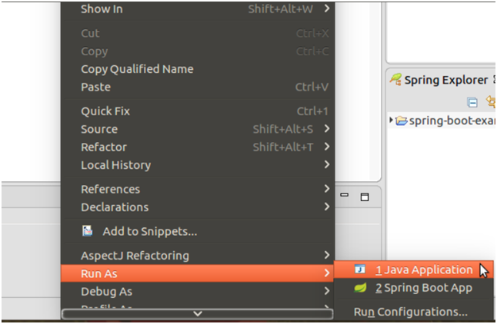
Now, open browser and follow the following URL.
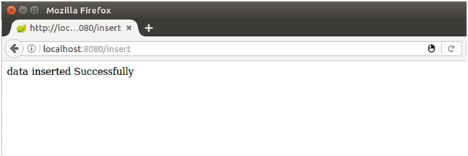
It says data has inserted successfully. Let’s confirm it by checking mysql table.
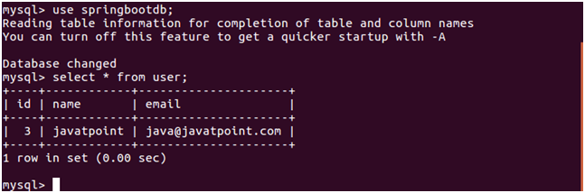
Well, our application is working fine. Now, we can perform other database operations as well.
- Where is Spring Boot Auto Configuration implemented?
All auto configuration logic is implemented in spring-boot-autoconfigure.jar. All auto configuration logic for mvc, data, jms and other frameworks is present in a single jar.
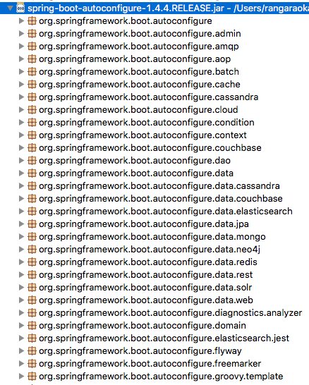
Other important file inside spring-boot-autoconfigure.jar is /META-INF/spring.factories. This file lists all the auto configuration classes that should be enabled under the EnableAutoConfiguration key. A few of the important auto configurations are listed below.
org.springframework.boot.autoconfigure.EnableAutoConfiguration=\
org.springframework.boot.autoconfigure.aop.AopAutoConfiguration,\
org.springframework.boot.autoconfigure.MessageSourceAutoConfiguration,\
org.springframework.boot.autoconfigure.PropertyPlaceholderAutoConfiguration,\
org.springframework.boot.autoconfigure.jackson.JacksonAutoConfiguration,\
org.springframework.boot.autoconfigure.jdbc.DataSourceAutoConfiguration,\
org.springframework.boot.autoconfigure.jdbc.JdbcTemplateAutoConfiguration,\
org.springframework.boot.autoconfigure.jdbc.JndiDataSourceAutoConfiguration,\
org.springframework.boot.autoconfigure.jdbc.XADataSourceAutoConfiguration,\
org.springframework.boot.autoconfigure.jdbc.DataSourceTransactionManagerAutoConfiguration,\
org.springframework.boot.autoconfigure.security.SecurityAutoConfiguration,\
org.springframework.boot.autoconfigure.security.SecurityFilterAutoConfiguration,\
org.springframework.boot.autoconfigure.web.DispatcherServletAutoConfiguration,\
org.springframework.boot.autoconfigure.web.EmbeddedServletContainerAutoConfiguration,
org.springframework.boot.autoconfigure.web.ErrorMvcAutoConfiguration,\
- What is Spring Boot Starter Parent?
All Spring Boot projects typically use spring-boot-starter-parent as the parent in pom.xml.
<parent>
<groupId>org.springframework.boot</groupId>
<artifactId>spring-boot-starter-parent</artifactId>
<version>1.4.0.RELEASE</version>
</parent>
Parent Poms allow you to manage the following things for multiple child projects and modules:
- Configuration - Java Version and Other Properties
- Depedency Management - Version of dependencies
- Default Plugin Configuration

